4.2. Design and Analysis of an FIR Low-Pass Filter Using the Hamming Window Technique in MATLAB

CODING:
clc;
clear;
close all;

%% --- Input Parameters ---
fp = 1000; % Passband cutoff (Hz)
fs = 4000; % Sampling frequency (Hz)
N = 50; % Filter order (even number preferred)

wc = fp/(fs/2); % Normalized cutoff frequency (0 to 1)

%% --- FIR Low Pass using Hamming Window ---
b_hamm = fir1(N, wc, 'low', hamming(N+1));
disp('--- Hamming Window Coefficients ---');
disp(b_hamm');

%% --- Plot Frequency Responses ---
figure;
freqz(b_hamm,1);
title('Low-pass FIR using Hamming Window');

OUTPUT: 1
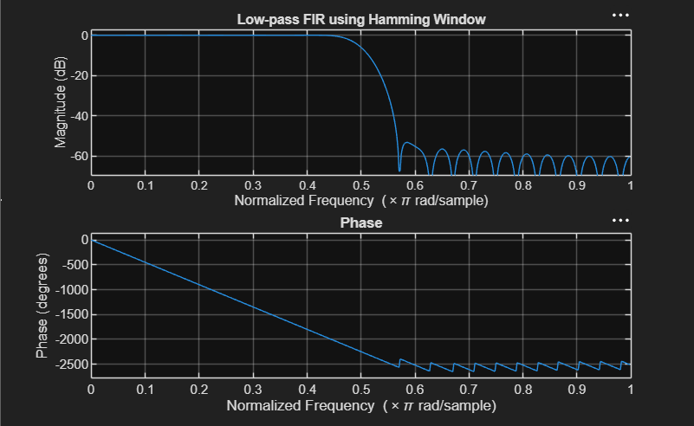

RESULT:
Hamming Window Coefficients ---
0.0010
0
-0.0013
0
0.0021
0
-0.0034
0
0.0055
0
-0.0084
0
0.0125
0
-0.0181
0
0.0260
0
-0.0379
0
0.0580
0
-0.1026
0
0.3168
0.4995
0.3168
0
-0.1026
0
0.0580
0
-0.0379
0
0.0260
0
-0.0181
0
0.0125
0
-0.0084
0
0.0055
0
-0.0034
0
0.0021
0
-0.001
0
0.0010

